
Working Title: Guilty as Arr!
Team: Melanie, Georgi Tsvetanski, Connor, Jeffrey T Dooms

competition
Guilty as Sock!
We took inspiration from this game, so ultimately it becomes our competitor. Both games use a courtroom styled setup where players argue, accuse, and defend themselves. Hence this one is a direct competition. However, we aim for a more pirate-themed game with a bit more flexibility in court.

Roblox
Roblox hosts a wide variety of games, many of them including role play and voice chats. It is one of the biggest titans in the multiplayer genre, so it is a big competitor with any other multiplayer game. Its voice chat feature is able to support around 50 players, compared to our smaller game. Role playing is one of Roblox’s selling points; the most popular game is Brookhaven RP with over 500,000 players. Our game is much smaller in scale, but focuses more on voice-based roleplay and social interaction.

Among Us
Among Us is a major influence on our game. It’s minimalistic, and very effective at creating fun tension through social deduction and discussion. It’s arguably the game that pioneered the genre. In our game, players will also accuse and defend each other, but with a pirate theme, courtroom scenes, and constant proximity based voice chat to make the experience more immersive and chaotic.

online community building
X (Twitter)
Many video games host accounts across all platforms to reach as many people as possible, but we will focus on X/Twitter. We will be able to write updates, post images to showcase progress, and better engage with a variety of people. Our handle will be @GuiltyAsArrDev.
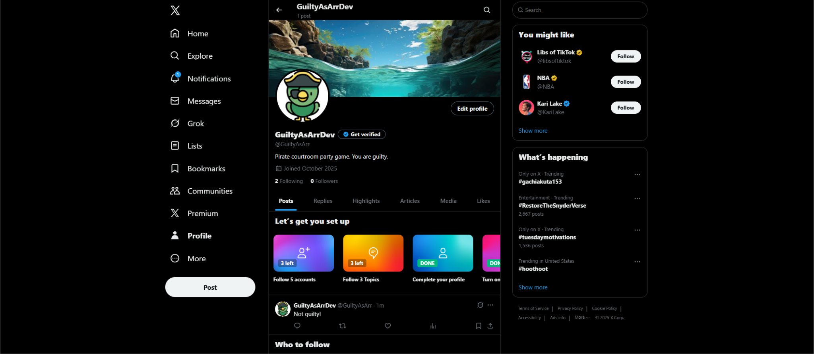
It is also important to consider Steam is our platform of choice for release, and it is automatically our secondary community building platform. Which is great, because all the players who own the game already are on the platform, and it has a very robust community newsletter system and comment sections. It’s a great place for input, answering the players questions without getting too close and personal, and growing a loyal audience by being transparent. A fantastic example is Repo.

marketing
Game Developers Conference (GDC)
San Francisco has a large video game industry, and naturally one of the biggest game conventions in the US. While this is a costly option, it is worth demonstrating our game where the people are. This conference has many advantages for small developers like being able to network and gather feedback, view new technology, and follow big industry leaders.

Steam Next Fest
Our game will have a home advantage at this week-long game festival hosted by Steam. While it may be harder to make connections virtually, it still gives us exposure and the ability for the steam community to discover our game. Since Steam will be our host platform, participating in Steam sponsored events will boost our project’s visibility. If we have a demo ready by this time, we would be able to gather an audience to begin anticipating our release.

Penny Arcade Expo (PAX)
PAX is another large game convention that hosts a variety of games from multiple developers, both big and small. It brings together a large community for exposure and garnering feedback. This convention is in person, so connecting with our audience will be more authentic and easier. Just like the others, we will be able to meet leaders in the gaming industry and network with others.

release
Steam
Despite costs (30% of revenue by default), Steam hosts a larger platform for newer games to gain a wider audience. While other platforms have low entry barriers, we believe investing in our game and earning back the entry fee. Not only are we aiming for a successful game launch, having a professional polished game hosted on a professional platform will be a great addition to our resumes.

