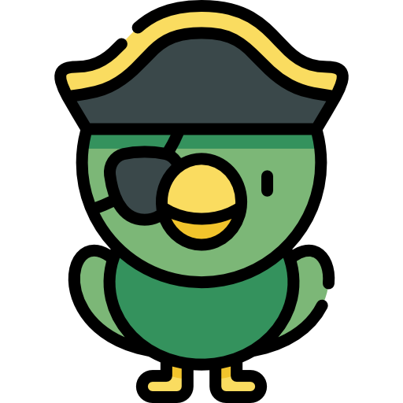

Guilty as Arrr! (ReScoped)
Team:
- Melanie
- Georgi Tsvetanski
- Jeffrey T. Dooms
Engine: Unity
Type: Minimal Multiplayer Social Deduction Prototype

Core Concept

Aboard the ship Guilty as Arrr, a mysterious crime has been committed.
The Captain calls for a court—one among the crew is the Saboteur responsible.
Players explore the ship and its nearby beach to uncover clues, mislead others, and accuse suspects.
Only the Captain holds the power to decide who walks the plank—but the sea often hungers for the innocent.

Gameplay Loop

1. Crime & Role Setup
- One or two Saboteurs are secretly chosen each round (based on player count).
- A Captain is randomly assigned and announced.
- The Captain receives a Crime Prompt (e.g., “Someone poisoned the rum!”).
- Every player receives a randomized Bio Profile including:
  - Physical traits: peg leg, hook hand, eyepatch, scar, height, tattoo, etc.
  - Habits or quirks: fond of rum, superstitious, keeps tools below deck, etc.
- The Saboteur’s profile matches certain clues that will later appear in the environment.
2. Exploration Phase (2 minutes)
Players freely explore the map to find clues and observe one another.
- Environments:
  - Ship Deck: barrels, cannons, lookout post.
  - Cabins & Quarters: bunks, maps, rum stash.
  - Beach Bay: footprints, discarded tools, wreckage, blood stains.
- Gameplay Details:
  - Random clues spawn according to the chosen crime and the Saboteur’s traits.
  - Example Clues:
    - “Wooden splinters near the broken chest.” $\rightarrow$ hints at peg leg.
    - “Rum stains by the Captain’s desk.” $\rightarrow$ hints at heavy drinker.
    - “Small muddy footprints by the ladder.” $\rightarrow$ hints at short crewmate.
  - Players can inspect clues to read short text descriptions, then use proximity voice chat to discuss—or deceive.
3. Court Phase
- All players return to the deck for the trial.
- Players argue using voice chat.
- Everyone votes for who they suspect.
- Votes are revealed to the Captain only—the Captain alone decides who walks the plank.
- The Captain can either follow or ignore the crew’s vote.
- The accused player is eliminated and becomes a ghost.
- This creates tension: players must convince not just their peers but the Captain.
4. Ghost System
- Eliminated players become ghosts, invisible to the living crew.
- Innocent ghosts may whisper once every 20 seconds—faint directional voice lines audible only to nearby players.
- Saboteur ghosts cannot whisper but can disturb the ship (sway lights, rattle objects).
- Ghosts may roam freely but cannot collect new clues.
- This mechanic keeps eliminated players engaged and adds paranoia to each round.
5. Verdict & Round End
- If the eliminated player was a Saboteur $\rightarrow$ the crew wins.
- If innocent $\rightarrow$ the game continues with one fewer crew member.
- When only Saboteurs remain $\rightarrow$ the Saboteurs win.
- The Captain role rotates for the next round.

Balancing

Player Count | Saboteur Count
4–5 Players | 1 Saboteur
6–10 Players | 2 Saboteurs
- A single Captain ensures clear leadership.
- Two Saboteurs in larger lobbies maintain chaos and uncertainty.

Example Scenario

- Case: “The Captain’s Parrot has vanished!”
- Saboteur Traits: short, hook hand, fond of rum.
- Clues Found:
  - “Rum stains beneath the cage.”
  - “Hook marks on the window frame.”
  - “Tiny footprints near the balcony.”
- After debate, the Captain declares: “Ye walk the plank, hook-handed fiend!”
- If wrong, the innocent ghost now haunts the ship, whispering eerie warnings.

Division of Labor

Role | Member | Responsibilities
Technical Designer / Programmer | Georgi Tsvetanski | Networking, role & crime logic, clue spawning, voting UI, ghost system, etc.
Environment Artist | Melanie | Ship and beach setup, lighting, prop placement, clue spots, plank animation, UI art, etc.
Writer / Systems Designer | Jeffrey T. Dooms | Case database, player traits, clue text, Captain dialogue, lore writing, documentation

Captain Gameplay System

The Captain is the most informed and influential player. While the crew explores, the Captain commands, observes, and analyzes the crew’s behavior.
Captain Tools & Actions
- Broadcast Orders (via Parrot Messenger)
  - Sends a parrot to deliver voiced orders to all players.
  - Example calls: “All hands, report to deck!” or “Search the lower quarters, you scallywags!”
  - Cooldown: 30 seconds.
- Crew Intel Reading
  - The Captain can read all player bios and note inconsistencies.
  - Example: A bio says “fear of water,” yet the player was seen near beach clues.
- Spyglass Observation
  - Activates a low-resolution or filtered zoom view for 15 seconds.
  - Cooldown: 45 seconds.
  - Highlights the last seen player (“Spotted near cannon deck”) on the Captain’s log.
- Investigation Pressure (Test)
  - Once per round, the Captain may trigger a chaotic event to test reactions.
  - Examples: “Shake the ship!” (camera shake), “Spill the rum!” (fake mess), or “Sound the cannon!”
- Deductions & Trial Control
  - During trial, the Captain may record notes: Suspicious / Neutral / Trustworthy.
  - The Captain can either:
    - Punish a player (walk the plank), or
    - Extend the investigation for another exploration round.
- Parrot Drone (Stretch Goal)
  - Send a parrot to follow one player for 15 seconds.
  - The parrot either records faint audio or marks unusual behavior (“lingering near evidence”).
  - Cooldown: once per round.
Why It Works
- Keeps the Captain active and engaged.
- Uses indirect influence rather than brute control.
- Encourages player psychology—power, fear, and manipulation.

Imposter Gameplay System

The Saboteurs secretly manipulate events and twist the truth. They must act discreetly—if caught, the Captain’s judgment will be swift.
1. Sabotage Actions (Stretch Goal)
- Spill Rum Barrel: Creates a fake clue puddle.
- Break Lantern: Darkens an area temporarily.
- Move a Clue: Relocates a genuine clue.
- Fake Cannon Blast: Creates noise and screen shake.
- Cooldown: 45 s—only once per round.
2. Deceptive Interactions (Personal Tricks)
- Fake Evidence Drop: Plant a forged clue (e.g., “Splinters near the ladder”).
- Erase Clue: Quietly remove a discovered clue.
- Rumor Whisper: Short private voice chat to a nearby player (15 s cooldown).
- Forgery Note: Drop a parchment “rumor” with custom short text.
3. Social Manipulation Tools
- Secret Mark (Skull Symbol): Imposters have a subtle skull icon on their bio cards, visible only to other imposters.
- Ally Signal: Silent ping between imposters once per round for coordination.
- Feign Trust: Whisper to a non-imposter and feed misinformation (“I think it’s the tall one…”).
4. Recommended MVP Implementation
For your first prototype, focus on these:
- Fake Evidence Drop
- Erase Clue
- Rumor Whisper
- Secret Mark / Ally Signal
This gives imposters agency and unpredictability without increasing scope. Add the sabotage actions later.
Why It Works
- Fits the tone—pirates lie, forge, and spread rumors.
- Enhances deception rather than overpowering it.
- Scalable, modular design.
- Encourages social interaction and mistrust.

Stretch Features

- Expanded sabotage events (storm, rum spill, fire).
- Dynamic weather changes during crimes (rain, fog).
- End-of-round summary revealing real culprits and false clues.
- Ghost spectator camera for cinematic playbacks.

Pitch Line

A social deduction prototype where the Captain’s judgment decides life or death—and even the dead refuse to stay silent.
“Among Us meets Ace Attorney—on a pirate ship.”
This looks very solid. The 2-minute exploration time feels much better for a map with three distinct zones.

